**Outline Overview:**

**Testing coverage:**

Testing Coverage for this website is limited from an automation perspective. Primarily due to the fact that currently I am unable to use existing google accounts for this test. I believe that this may be a security measure put in place by google. An error message *"Couldn’t Sign you in*" will get you displayed (*Link to Issue:* [*https://support.google.com/accounts/thread/10916318?hl=en*](https://support.google.com/accounts/thread/10916318?hl=en)). Hence to solve this problem I found that creating a new account for this test in the automation browser window that was generated, worked.

This issue is also present when testing the forgot password and creation of new accounts, due to the fact that these processes require external verification methods, such as two factor authentication with either phone or email. Hence to validate and test these functionalities, I verified that the user is able to get to the last page just before they are asked for external verification.

**Technical Aspect.**

To convert Manual Test Cases to UI Automation Scripts I have decided to use CucumberBDD in order to achieve this. Besides the main google sign in account issue, there were no other technical issues that I incurred whilst testing. I have added both the Chrome driver and Firefox’s Gecko Driver, this is to ensure cross browser compatibility and to ensure that the script will work on multiple browsers. To run the test I ran the cucumber feature file to run the automation tests.

**Final Results Screenshots**

After running the script, the final results are displayed below in the console. All tests passed as expected.

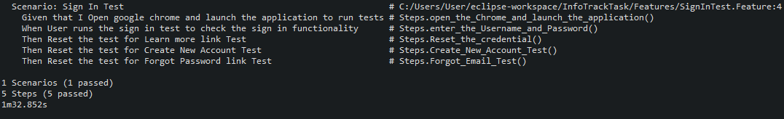

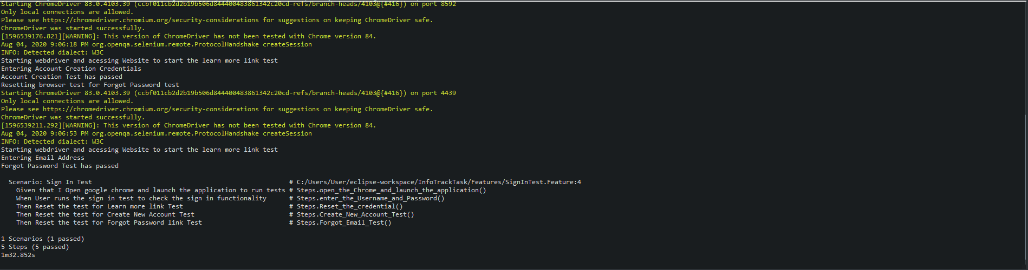

All test have passed.

**Additional Notes**

* Some additional findings which I noticed in my testing, was that in 1 in every 5 tests that I ran, the automation would stop. This normally doesn’t happen and am unsure as to why it did, but I found that if I ran the test again it would work as expected.